
WISER: Women’s Institutes and Seismic Engineering Research Workshops

SCIENCE KIT

Understanding How Earthquakes Make Buildings Vibrate

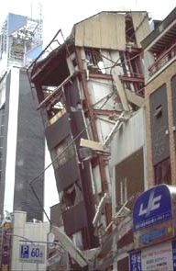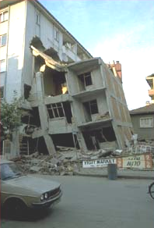With the simple and cheap materials listed below, you can work through the experiments on these sheets to find out how earthquakes cause some buildings to vibrate while others seem to stand still.

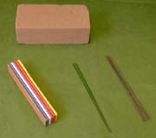
You will need these materials:

Plasticine

Bags of florists' wire (The same lengths but different thicknesses)

A block of polystyrene or florists' dry oasis (about 20x10x10 cm)

The plasticine and wires will be used to make very simple models of buildings, and the polystyrene block will represent the ground that supports the building.


Prepared by the with funding from

Natural Frequency Experiment – 1
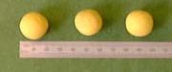
Step 1: Roll three pieces of plasticine into balls of about 2 cm in diameter or 8 grams in weight.

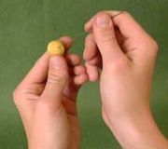
Step 2: Choose 3 wires all of the same thickness. Stick the end of each wire into the middle of a plasticine ball.

Note: Make sure the wire is in the middle of the ball, otherwise the experiment will not work well.

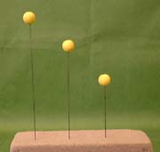
Step 3: Stick the 3 ball-and-wires into the polystyrene block, so that they stand upright. Push them in by different amounts so that they are different heights, e.g. 10 cm, 15 cm and 20 cm.

These 3 ball-and-wires are models of 3 buildings of different height. For each one, the plasticine ball represents the weight of the building and the steel wires represent the flexibility of the building.

When you look at a building, you probably think of it as a rigid structure. But all buildings have some flexibility - for example they sway in the wind. However, they only move a little bit, and you can’t see it, but the fact they can move means that they are flexible. Sometimes, you can feel a very tall building swaying if you are on the top floor on a particularly windy day.

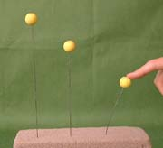
Step 4: Pull the ball on the tallest wire back about 3 cm and let go.

Notice how the ball sways backwards and forwards with a regular rhythm (or beat) even when the motion is dying out. Even when you start with the ball pulled further back, the rhythm of the sway remains the same. The number of times the ball sways to-and-fro every second is the NATURAL FREQUENCY of the ball-and-wire.

Note: Don’t bend the wires over too much or they will stay bent.

Step 5: Repeat this step for the balls on the shorter wires as well.

Question: Which one has the highest natural frequency?
(Hint: This will be the one that sways backwards and forwards the fastest.)

You should have said the shortest wire, which made the ball-and-wire system stiffer. This is similar for buildings. Shorter buildings tend to be stiffer and to have higher natural frequencies while taller buildings tend to be more flexible and to have lower natural frequencies.

Step 6: Take the ball-and-wires out of the polystyrene block and pull the wires out of the balls.
Natural Frequency Experiment - 2

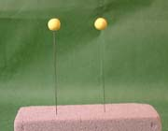
Step 1: Re-roll two of the balls. Then choose 2 wires each of different thickness. Insert them into the balls. Push both wires into the polystyrene block so that they stand upright to the same height, e.g. 10 cm.

Note: Make sure that you stick the wires in a new position in the block or the experiment won't work very well.

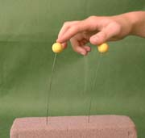
Step 2: Pull both balls back about 3 cm, then let them go.

Question: Does the ball with the thicker or thinner wire have the higher natural frequency?

You should have noticed that it was the thicker wire, which made the ball-and-wire system stiffer. This is similar for a narrow and wide building of the same height. The wider building will generally have a higher natural frequency because it is stiffer.

Step 3: Take the ball-and-wires out of the polystyrene block and pull the wires out of the balls.

Natural Frequency Experiment – 3

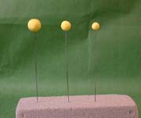
Step 1: Using the same thickness of wire, try lengths of 15 cm sticking out of the polystyrene block, but use different sizes of plasticine balls. Try pulling all three once and compare them.

Hint: If you can't see a difference, then make the largest ball a bit bigger and the smallest one smaller until you can.

Question: Which ball-and-wire has the lowest natural frequency?

You should have said the one with the largest ball. This is similar for buildings of the same height, but made from different materials. The heavier building will generally have a lower natural frequency.

Step 2: Take the balls and wires out of the polystyrene block and pull the wires out of the balls.

Now you understand that buildings can sway at their natural frequency

Actually, buildings have more one natural frequency. In fact, each building has a whole set of its own, and the building can vibrate with a different shape for each frequency. If you want to find out more about this, go to http://www.ideers.bris.ac.uk/resistant/vibrating_build.html

so move on to discover how buildings RESONATE during earthquakes.

Resonance Experiment

Step 1: Roll two pieces of plasticine into balls of different sizes, e.g. about 1 cm and 2 cm in diameter.

Step 2: Choose 2 wires of the same thickness. Stick the end of each wire into the middle of a plasticine ball.

Note: Make sure the wire is in the middle of the ball, otherwise the experiment will not work well.

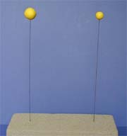
Step 3: Stick the 2 wires with the balls into the polystyrene block, so that they stand upright. Push them in so that they are the same height, about 20 cm.

In this experiment, think of the polystyrene block as being the ground that the buildings (i.e. the ball-and-wire models) are supported on.

Step 4: Pull the bigger ball back about 3 cm and let go. Make a mental note of the natural frequency of its backwards and forwards motion. You can do this by tapping your hand on the table with a beat in time with the motion. Keep this in your mind.

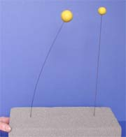
Step 5: Now start pushing the polystyrene block backwards and forwards gently at the same frequency, i.e. in time with the beat you noted. You are now creating an earthquake by making the ground (i.e. the polystyrene block) move.

Question: What happens?

You should have noticed that the wire with the bigger ball swayed a lot while the one with the smaller ball only moved a little. This is because you caused RESONANCE of the large ball-and-wire.

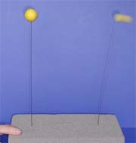
Step 6: Repeat steps 4 and 5 for the small ball.

Question: What happens?

You should have noticed that the wire with the smaller ball swayed a lot while the other one hardly moved. This time you caused RESONANCE of the small ball-and-wire.

Now you have seen resonance, move on to find out how earthquakes cause buildings to sway
How Earthquakes Make Buildings Resonate


For a building, resonance occurs when the frequency of the ground motion matches the natural frequency of the building.

Note: The frequency of the ground motion is the number of times each second that the ground moves backwards and forwards with a regular rhythm.

If the ground vibrated at a different frequency, the building would not vibrate as strongly. In fact the building's vibrations get much smaller, as the frequency of shaking moves further away from the natural frequency of the building. You can try this with your ball-and-wire experiment.

Of course, the ground motion in an earthquake is a lot more complicated than this. It does not have one frequency of vibration, but it is made up from a mixture of frequencies, and the energy at some frequencies is a lot more than at others. A building will vibrate more when any of the frequencies of the ground motion are close to one of its natural frequencies, and it will be vibrate even more when there is a lot of energy at that frequency. Buildings which have their natural frequencies higher or lower than the main frequencies of vibration of the ground motion will tend to vibrate less or hardly at all.

If the resonance of a building builds up too much during an earthquake, damage and even collapse can occur, if the building has not been properly designed for earthquakes, or if it has not been constructed properly. If you want to find out how engineers design buildings to resist earthquakes, visit http://www.ideers.bris.ac.uk/resistant/

So, now you understand how and why some buildings vibrate more than others during an earthquake.

